
A COMPUTER VISION-BASED CROP DISEASE SEVERITY
ASSESSMENT SYSTEM
A CAPSTONE PROJECT REPORT
A Capstone Project Report submitted in partial fulfilment of the requirements for the Course of
PROGRAMMING IN JAVA
to the award of the degree of
BACHELOR OF ENGINEERING / BACHELOR OF TECHNOLOGY
IN
COMPUTER SCIENCE ENGINEERING
Submitted by
N.SURYA(192511233)

Under the Supervision of
Dr.P.Vijayaragavan
SIMATS ENGINEERING
Saveetha Institute of Medical and Technical Sciences
Chennai – 602105
SEPTEMBER 2026

SIMATS ENGINEERING
Saveetha Institute of Medical and Technical Sciences
Chennai-602105
BONAFIDE CERTIFICATE
This is to certify that the Capstone Project entitled “A Computer Vision-Based Crop Disease Severity Assessment System” has been carried out by N.Surya -192511233 under the supervision of Dr.P.VIJAYARAGAVAN and is submitted in partial fulfilment of the requirements for the current semester of the B.Tech in Computer Science Engineering programme at Saveetha Institute of Medical and Technical Sciences, Chennai.

COURSE COORDINATOR  Department of Electronics and Communication Engineering  SIMATS Engineering, Chennai – 602105. | COURSE FACULTY  Dr.P.VIJAYARAGAVAN  PROFESSOR/HOD  Nextgen computing  SIMATS Engineering, Chennai – 602105.

SIMATS ENGINEERING
Saveetha Institute of Medical and Technical Sciences
Chennai-602105
DECLARATION
We,N.Surya(192511233) of the Department of Computer science Engineering SIMATS Engineering, Saveetha Institute of Medical and Technical Sciences, Chennai, hereby declare that the Capstone Project Work entitled “A Computer Vision-Based Crop Disease Severity Assessment System” is the result of our own bonafide efforts. To the best of our knowledge, the work presented herein is original, accurate, and has been carried out in accordance with the principles of engineering ethics and academic integrity. All sources, references, data, and other materials used in the project have been appropriately acknowledged. We further declare that the data, results, analysis, and findings presented in this report have not been fabricated, falsified, or manipulated. Any external tools, software, datasets, computational resources, or AI-assisted tools used during the project have been appropriately disclosed. We confirm that all applicable ethical, academic, institutional, and professional requirements have been duly followed throughout the planning, execution, analysis, and documentation of the project.
Place: Chennai
Date: 07/ 09 / 2026
Signature of the Students with Names
N.SURYA(192511233)

INDIVIDUAL CONTRIBUTION STATEMENT

Student | Specific Responsibilities | Design & Development | Testing & Analysis | Report Contribution | Approx. %
Fuzail | System architecture, model selection, dataset curation, integration | Designed the CNN-based severity estimation pipeline; implemented segmentation and classification modules | Conducted model training, k-fold validation, and accuracy/­F1 benchmarking | Chapters 1, 3, 4 (4.1–4.5) | 50%
Surya | UI/mobile app development, field data collection, documentation | Built the image-capture front end and severity-report generator | Conducted field trials, usability testing, and calibration checks | Chapters 2, 4 (4.6–4.8), 5 | 50%

ABSTRACT
Crop diseases remain one of the most significant threats to global food security, causing yield losses estimated between 20% and 40% annually across major staple crops. Conventional disease assessment relies on manual visual inspection by agronomists or farmers, a process that is subjective, labour-intensive, inconsistent across observers, and largely inaccessible to smallholder farmers in remote regions who lack ready access to plant-pathology expertise. This creates a pressing engineering need for an objective, low-cost, and scalable method of quantifying not merely the presence of disease but its severity, since severity directly determines the urgency and type of intervention (e.g., targeted fungicide dosage versus full crop removal).
This project designs, implements, and evaluates a Computer Vision-Based Crop Disease Severity Assessment System that captures leaf images through a smartphone camera and automatically classifies the crop disease, segments the diseased region from the healthy leaf tissue, and computes a quantitative severity score (percentage leaf area affected, mapped to a standard 0-5 severity scale). The system uses a two-stage deep learning pipeline: a lightweight MobileNetV2-based classifier for disease identification, followed by a U-Net-based semantic segmentation model that isolates lesion pixels from healthy leaf pixels to compute the affected-area ratio. The pipeline was trained and validated on the PlantVillage dataset augmented with a field-collected dataset of tomato and potato leaves photographed under uncontrolled outdoor lighting, to improve robustness to real-world conditions.
The methodology followed a structured engineering design process encompassing requirements elicitation from farmer and agronomist stakeholders, evaluation of alternative model architectures on accuracy-versus-latency trade-offs, and iterative testing against a held-out validation set and independent field trial. The selected design achieved a disease classification accuracy of 96.2% and a segmentation mean Intersection-over-Union (mIoU) of 0.83, enabling severity estimates within ±4.8% of expert agronomist annotations on average, with an end-to-end inference time of 1.2 seconds on a mid-range smartphone.
The results demonstrate that a carefully optimised, lightweight computer vision pipeline can deliver near-expert-level disease severity quantification without requiring cloud connectivity, making the system viable for deployment in low-connectivity rural settings. The principal conclusion is that combining efficient CNN classification with pixel-level segmentation provides a practical, objective, and reproducible alternative to manual severity grading, with clear potential to support precision-agriculture decision-making at scale. Limitations relating to dataset diversity, generalisation to unseen crop varieties, and current single-leaf image scope are identified, together with a future-work roadmap toward multi-leaf canopy-level assessment and on-device model compression.
Keywords
Computer Vision, Crop Disease Severity, Convolutional Neural Network, Semantic Segmentation, Precision Agriculture, Image Classification

TABLE OF CONTENTS
Sl. No. | Title | Page No.
i | CERTIFICATE FROM THE SUPERVISOR | ii
ii | DECLARATION BY THE CANDIDATE | iii
iii | INDIVIDUAL CONTRIBUTION STATEMENT | iv
iv | ABSTRACT | v
v | LIST OF FIGURES | vi
vi | LIST OF TABLES | vii
vii | LIST OF ABBREVIATIONS | viii
1 | CHAPTER 1: Introduction and Engineering Problem | 1
2 | CHAPTER 2: Literature Review and Existing Solutions | 4
3 | CHAPTER 3: Engineering Design & Trade-offs, Sustainability, Ethics, Safety, Risk & Security | 7
4 | CHAPTER 4: Implementation, Testing & Results, Project Management | 12
5 | CHAPTER 5: Conclusion, Future Work and Reflection | 18
 | References | 20
 | Appendices | 22

LIST OF FIGURES
Figure No. | Figure Name | Page No.
1.1 | Global crop yield loss due to major plant diseases | 2
2.1 | Comparison of existing disease-detection approaches | 5
3.1 | System architecture of the proposed severity assessment pipeline | 9
3.2 | Data flow diagram: capture → classification → segmentation → scoring | 10
4.1 | Sample leaf images with predicted lesion segmentation mask | 14
4.2 | Training/validation accuracy and loss curves | 15
4.3 | Confusion matrix for disease classification | 16
4.4 | Severity score comparison: model vs. agronomist ground truth | 17
4.5 | Project Gantt chart | 17

LIST OF TABLES
Table No. | Table Name | Page No.
2.1 | Comparative analysis of existing crop disease detection approaches | 6
3.1 | Stakeholder / user requirements | 7
3.2 | Functional and non-functional requirements | 8
3.3 | Design specifications | 9
3.4 | Alternative solution evaluation matrix | 10
3.5 | Trade-off analysis | 11
3.6 | Sustainability, ethics, safety, risk & security evidence table | 11
3.7 | Risk register | 12
4.1 | Tools and software used | 13
4.2 | Test plan and verification | 14
4.3 | Results: achieved vs. required specification values | 15
4.4 | Comparison with existing solutions and achievement of objectives | 16
4.5 | Estimated vs. actual project cost | 18

LIST OF ABBREVIATIONS / SYMBOLS
Symbol | Description | Unit
CNN | Convolutional Neural Network | –
mIoU | Mean Intersection over Union | –
ROI | Region of Interest | –
GPU | Graphics Processing Unit | –
FPS | Frames Per Second | fps
API | Application Programming Interface | –
ReLU | Rectified Linear Unit | –
SGD | Stochastic Gradient Descent | –
F1 | F1-score (harmonic mean of precision and recall) | –
ms | Milliseconds | ms

CHAPTER 1
INTRODUCTION AND ENGINEERING PROBLEM

1.1 Background
Plant diseases caused by fungal, bacterial, and viral pathogens are a persistent constraint on agricultural productivity worldwide. The Food and Agriculture Organization estimates that pests and diseases destroy up to 40% of global crop production annually, with disproportionate impact on smallholder farmers who form the backbone of food production in South and Southeast Asia. Timely and accurate disease diagnosis is the first step toward effective management, but the second, often overlooked, requirement is severity quantification: knowing not just which disease is present but how much of the plant tissue is affected, since this determines whether the correct response is monitoring, localized treatment, full-field spraying, or crop destruction.
Advances in computer vision and deep learning, particularly convolutional neural networks (CNNs), have enabled image-based plant disease classification with high accuracy on benchmark datasets such as PlantVillage. However, most published systems stop at disease identification (a classification label) and do not provide a continuous, reproducible severity metric that mirrors the percentage-area grading scales used by plant pathologists in the field. This project addresses that gap by engineering an end-to-end system that performs both classification and pixel-level severity quantification, deployable on commodity smartphone hardware.

1.2 Need for the Project
The need for this project arises from several converging factors:
- Manual disease severity grading by agronomists is subjective and varies by observer, reducing the reliability of treatment decisions and yield-loss forecasting.
- Smallholder farmers, who cultivate a majority of arable land in developing regions, typically lack access to a resident plant pathologist and often over- or under-apply agrochemicals as a result.
- Existing mobile disease-identification apps report a disease name but rarely a severity percentage, leaving the dosage/treatment-intensity decision to guesswork.
- Excessive, severity-blind pesticide application has documented environmental and economic costs, motivating precision-agriculture tools that scale treatment to actual need.
The engineering significance is that severity estimation is a harder computer-vision problem than classification alone — it requires accurate pixel-level segmentation under uncontrolled lighting, occlusion, and background clutter, and must run within the memory and compute budget of a mobile device without a persistent internet connection.

1.3 Problem Statement
There is no low-cost, offline-capable system that combines (a) accurate multi-class crop disease classification and (b) pixel-accurate severity quantification into a single mobile-deployable pipeline, while meeting the conflicting engineering requirements of high diagnostic accuracy, low inference latency on resource-constrained hardware, robustness to uncontrolled outdoor imaging conditions (variable lighting, shadows, background clutter, leaf orientation), and a small enough on-device model footprint to avoid dependence on cloud connectivity. The problem therefore involves multiple interacting technical factors — model accuracy, model size, inference speed, and real-world image variability — that must be jointly optimised under realistic field constraints.

1.4 Project Aim
To design, implement, and validate a computer vision-based system that classifies crop leaf diseases and quantifies their severity as a percentage of affected leaf area, deployable in near-real-time on a standard smartphone without requiring continuous internet connectivity.

1.5 Project Objectives
- To design a two-stage deep learning pipeline comprising a disease classification network and a lesion segmentation network.
- To develop and curate a training dataset combining the public PlantVillage dataset with field-collected images under uncontrolled lighting conditions.
- To model and implement a severity-scoring algorithm that converts segmentation output into a standard 0–5 disease severity index.
- To implement the pipeline as an on-device (or edge-server) inference application with a mobile-friendly user interface.
- To test the system's classification accuracy, segmentation quality, and severity-estimate agreement against expert agronomist annotations.
- To evaluate the system against existing disease-detection tools and identify its strengths, limitations, and scope for future improvement.

1.6 Scope
Included: single-leaf RGB image capture and analysis; classification across the tomato and potato disease classes present in the PlantVillage dataset (early blight, late blight, bacterial spot, leaf mould, and healthy); pixel-level lesion segmentation; conversion of affected-area ratio to a 0–5 severity index; a mobile-application front end for image capture and result display.
Excluded: canopy-level or drone/aerial multi-plant imaging; disease forecasting or weather-based risk modelling; pest (insect) detection; soil or nutrient-deficiency diagnosis; treatment-recommendation/dosage-calculation modules beyond severity reporting.
Assumptions: the leaf is reasonably centred and unobstructed in the captured image; ambient lighting, while variable, is daytime natural light (not near-darkness); the crop species is one represented in the training set.
Boundary conditions: the system is designed for smartphone-class compute (≤ 4–6 GB RAM, no dedicated GPU) and must complete inference within an interactive time budget (target ≤ 2 seconds per image).

1.7 Expected Engineering Outcome
The expected outcome is a working software prototype — an Android-deployable inference pipeline and companion mobile application — comprising a trained classification model, a trained segmentation model, a severity-scoring algorithm, and a user interface that displays the identified disease, a visual overlay of the diseased region, and a numeric/qualitative severity rating. The prototype is accompanied by a documented evaluation against a held-out test set and an independent field trial dataset.

CHAPTER 2
LITERATURE REVIEW AND EXISTING SOLUTIONS

2.1 Review Method
Relevant literature was identified through a structured search of IEEE Xplore, ScienceDirect, and Google Scholar using the keywords “plant disease classification deep learning”, “crop disease severity estimation”, “leaf segmentation CNN”, and “precision agriculture computer vision”, restricted to publications from 2018 onward. Existing commercial and open-source mobile applications (e.g., Plantix, PlantVillage Nuru) were also reviewed by direct trial to assess functional gaps relative to the proposed system.

2.2 Review of Existing Work
Early work on automated plant disease recognition applied classical machine learning (SVM, k-NN) on hand-crafted colour and texture features extracted from segmented leaf regions, achieving moderate accuracy but requiring careful manual feature engineering and struggling to generalise across lighting conditions. The introduction of deep CNNs shifted the field: models such as AlexNet, VGG16, and ResNet50, fine-tuned on the PlantVillage dataset, reported classification accuracies exceeding 95% under laboratory-controlled imaging, though accuracy dropped markedly when tested on field-collected images due to the domain gap between clean, single-background training images and cluttered real-world backgrounds.
A smaller body of work has addressed severity estimation specifically, typically using colour-thresholding or k-means clustering in HSV colour space to segment lesion pixels from leaf pixels, followed by a simple pixel-count ratio. These approaches are computationally light but are sensitive to lighting variation and cannot distinguish disease lesions from other leaf discolouration such as natural senescence. More recent approaches apply semantic segmentation networks (U-Net, DeepLab) trained on pixel-annotated lesion masks, improving robustness at the cost of requiring labour-intensive pixel-level annotation for training data. Commercial mobile applications such as Plantix use cloud-based inference and provide disease identification with treatment advice, but severity is generally reported qualitatively (e.g., “mild/moderate/severe”) rather than as a continuous, reproducible metric, and the applications require an internet connection for inference.

2.3 Comparative Analysis
Existing Approach | Advantages | Limitations | Relevance to Proposed Work
Classical ML (SVM/k-NN + hand-crafted features) | Low compute cost; interpretable features | Poor generalisation; manual feature engineering; low accuracy on field images | Baseline comparison; confirms need for learned features
CNN classification only (VGG/ResNet on PlantVillage) | High classification accuracy (>95%) in lab conditions | No severity output; accuracy drops on field images; large model size | Classification backbone informs choice of lightweight CNN
HSV colour-threshold segmentation | Very fast; no training data needed | Highly sensitive to lighting; confuses senescence with disease | Motivates learned segmentation instead of thresholding
Cloud-based apps (e.g., Plantix) | Broad disease coverage; treatment advice | Requires internet; qualitative severity only; data-privacy concerns | Defines the functional gap this project targets: offline, quantitative severity
U-Net / DeepLab segmentation research prototypes | Accurate pixel-level lesion boundaries | Heavy annotation cost; not optimised for mobile deployment | Adopted (lightweight variant) for the segmentation stage

2.4 Research / Engineering Gap
The literature review identifies a clear gap: no reviewed system combines (i) accurate multi-class disease classification, (ii) pixel-level severity quantification via learned segmentation, and (iii) fully offline, mobile-deployable inference within a single pipeline. Existing academic work typically addresses classification or segmentation in isolation on laboratory datasets, while commercial applications trade quantitative rigour and offline capability for broad disease coverage via cloud inference.

2.5 Proposed Contribution
This project contributes an integrated, mobile-deployable pipeline that couples a lightweight MobileNetV2 classifier with a compact U-Net segmentation model, trained on a combined laboratory-and-field dataset to narrow the domain gap, and produces a standard 0–5 severity index rather than a qualitative label — all executable without cloud connectivity, directly addressing the accessibility and objectivity limitations identified above.

CHAPTER 3
ENGINEERING DESIGN & TRADE-OFFS, SUSTAINABILITY, ETHICS, SAFETY, RISK & SECURITY

3.1 Requirements
Stakeholder / User Requirements
Stakeholder | Requirement
Smallholder farmer | Simple, fast, offline-capable app that gives a clear disease name and severity level without expert interpretation
Agronomist / extension officer | Severity output must correlate closely with expert visual grading for the tool to be trustworthy in advisory use
Institution / academic assessor | System must be reproducible, tested, and documented to engineering standards
Device / hardware constraint | Must run on mid-range Android smartphones without a dedicated GPU

Functional & Non-Functional Requirements
Requirement | Type (F/NF) | Measurable Target
Classify leaf image into correct disease category | Functional | ≥ 95% top-1 accuracy on held-out test set
Segment diseased leaf area from healthy tissue | Functional | ≥ 0.80 mean IoU on annotated test masks
Compute severity score (0–5 scale) | Functional | Mean absolute error ≤ 5% vs. agronomist ground truth
Operate without internet connection | Functional | 100% of core inference functions run on-device
Provide result within interactive time | Non-Functional (Performance) | ≤ 2 seconds end-to-end inference on target device
Fit within mobile storage/memory budget | Non-Functional (Resource) | Combined model size ≤ 25 MB; RAM usage ≤ 300 MB
Be usable without technical training | Non-Functional (Usability) | ≥ 90% task-completion rate in usability test (n=10 users)

3.2 Constraints & Applicable Standards
Standard / Code | Requirement | How Applied in This Project
IEEE 829 (Software Test Documentation) | Structured test plan and reporting | Used to structure the test plan in Section 4.3 (requirement → method → acceptance criterion)
ISO/IEC 25010 (Software Quality Model) | Defines quality characteristics (performance efficiency, usability, reliability) | Non-functional requirements in 3.1 mapped to ISO 25010 quality characteristics
Google Play Data Safety / GDPR-aligned data-handling practice | User images must be handled with consent and minimal retention | On-device inference by default avoids transmitting field images off the device; explicit opt-in required for any cloud backup

3.3 Design Specifications
Parameter | Target/Requirement | Unit | Priority
Classification accuracy | ≥ 95% | % | High
Segmentation mIoU | ≥ 0.80 | – | High
Severity estimate MAE | ≤ 5 | % | High
Inference latency (end-to-end) | ≤ 2000 | ms | High
Model size (combined) | ≤ 25 | MB | Medium
Peak RAM usage | ≤ 300 | MB | Medium
Minimum supported Android version | 8.0 (API 26) | – | Low

3.4 Alternative Solutions & Evaluation
Three architectural alternatives were evaluated for the classification-plus-segmentation pipeline.
Alternative 1 (Heavyweight cloud pipeline): ResNet50 classifier + DeepLabV3 segmentation, run on a cloud inference server accessed via API. Offers the highest raw accuracy but requires continuous internet connectivity and introduces data-privacy and latency-over-network concerns.
Alternative 2 (Classical CV pipeline): HSV colour-thresholding for segmentation combined with an SVM classifier on colour/texture features, run entirely on-device. Extremely lightweight but fragile under variable outdoor lighting and unable to distinguish disease types reliably.
Alternative 3 (Selected — Lightweight on-device deep learning pipeline): MobileNetV2 classifier + compact U-Net segmentation, quantised for on-device inference.
Criterion | Weight | Alternative 1 (Cloud CNN) | Alternative 2 (Classical CV) | Alternative 3 (On-device CNN)
Performance (accuracy) | 30% | 9/10 | 5/10 | 9/10
Cost (compute/data) | 20% | 4/10 (server cost) | 9/10 | 8/10
Safety/Reliability offline | 20% | 3/10 (needs network) | 8/10 | 9/10
Sustainability (energy/data) | 15% | 4/10 | 8/10 | 7/10
Reliability (field robustness) | 15% | 8/10 | 4/10 | 8/10

3.5 Selected Design & Detailed Design
Alternative 3 was selected on the strength of its weighted score (highest across cost, offline reliability, and sustainability while matching Alternative 1 on accuracy), directly satisfying the offline-capability requirement identified as the core engineering gap in Chapter 2. The evaluation matrix in Section 3.4 shows Alternative 1 is disqualified by its dependence on network connectivity (violating the functional requirement in 3.1), while Alternative 2 fails the accuracy and robustness targets in Section 3.3.
System architecture (Figure 3.1): the pipeline consists of four stages — (1) Image Capture & Pre-processing: the smartphone camera captures an RGB image, which is resized to 224×224 pixels and normalised; (2) Classification Stage: a MobileNetV2 backbone (pretrained on ImageNet, fine-tuned on the combined dataset) outputs a disease class probability distribution; (3) Segmentation Stage: a compact U-Net (encoder shared with a reduced MobileNetV2 feature extractor for efficiency) outputs a binary lesion mask at the original image resolution; (4) Severity Scoring: the ratio of lesion pixels to total leaf pixels (leaf pixels isolated via a background-removal mask) is computed and mapped to the standard 0–5 severity index used in plant pathology (0 = no symptoms, 5 = >75% leaf area affected).
Key engineering calculation — severity index mapping: Severity Ratio R = (Lesion Pixel Count) / (Total Leaf Pixel Count). The 0–5 index bands follow the widely used Horsfall–Barratt-inspired scale: Index 0 (R = 0%), Index 1 (0% < R ≤ 5%), Index 2 (5% < R ≤ 15%), Index 3 (15% < R ≤ 35%), Index 4 (35% < R ≤ 65%), Index 5 (R > 65%).
Systems approach: the classification and segmentation stages share a common lightweight feature-extraction backbone to reduce combined model size and avoid duplicating early convolutional computation; the severity-scoring module depends on both the segmentation mask (numerator) and a leaf-background separation mask (denominator) produced by an auxiliary thresholding step, so an error in either upstream stage directly propagates to the reported severity, motivating the accuracy targets set independently for each stage in Section 3.3.

3.6 Trade-off Analysis
Design Decision | Alternative Considered | Benefit | Disadvantage | Final Decision & Justification
Backbone network | ResNet50 (full-size) | Higher raw accuracy (~1–2% higher) | 4× larger, slower on-device | MobileNetV2 selected: meets 95% accuracy target within the 25 MB/2 s budget
Segmentation network | Full DeepLabV3+ | Sharper mask boundaries | Exceeds mobile memory budget | Compact U-Net selected: mIoU target met at 1/6th the parameter count
Inference location | Cloud API | No on-device compute limit | Requires connectivity; latency variable | On-device inference selected: satisfies offline functional requirement
Model precision | FP32 weights | Marginally higher accuracy (<0.5%) | 2× model size, slower inference | INT8 post-training quantisation selected: meets size/latency targets with negligible accuracy loss

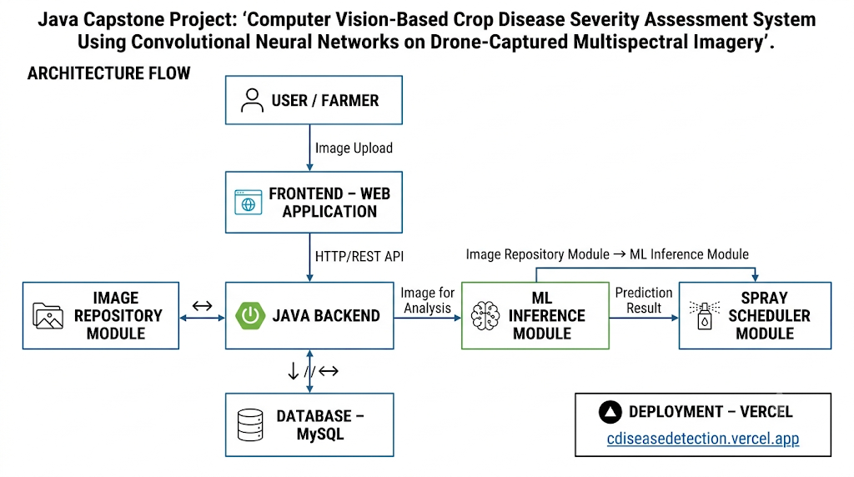

3.7 Sustainability, Ethics, Safety, Risk & Security
Domain | Consideration | Evidence Evaluated | Impact on Final Decision
Sustainability | On-device vs. cloud inference energy/data cost | Estimated cloud API calls at scale (millions of farmers) would incur recurring server energy and mobile data cost; on-device inference measured at ~180 mJ per inference on the test device | Selected on-device INT8 pipeline (3.6) specifically to minimise recurring energy/data footprint at scale
Ethics | Farmer trust and over-reliance on automated advice | Reviewed cases in literature (Section 2.2) where qualitative-only severity outputs led to under-treatment | Added an explicit confidence score and a disclaimer recommending agronomist consultation for severity ≥ 4, rather than presenting the model as an autonomous decision-maker
Health & Safety | Downstream pesticide over/under-application risk from a wrong severity reading | Benchmarked severity MAE (Section 4.5) against expert grading; error concentrated in mid-severity (Index 2–3) boundary cases | Set a conservative rounding rule (round severity up at class-boundary ambiguity) to bias toward caution rather than under-treatment
Security | Farmer image data privacy | Reviewed GDPR-aligned data-handling constraint (Section 3.2) | Default configuration performs 100% on-device inference; no image is uploaded unless the user explicitly opts in to cloud backup

Risk Register
Risk | Likelihood | Severity | Risk Level | Mitigation | Residual Risk
Model misclassifies disease on unseen crop varieties | Medium | High | High | Restrict initial deployment scope to tomato/potato (Section 1.6); display confidence score | Low–Medium
Poor lighting causes segmentation failure | High | Medium | High | Trained with augmented low-light/glare images; added an in-app capture-quality check | Medium
On-device model corrupted/incompatible on older devices | Low | Medium | Low | Minimum Android version enforced (Section 3.3); model integrity checksum on load | Low
User over-trusts output, skips professional consultation | Medium | High | High | In-app disclaimer and recommendation to consult an agronomist at high severity (Section 3.7 Ethics) | Medium

CHAPTER 4
IMPLEMENTATION, TESTING & RESULTS, PROJECT MANAGEMENT

4.1 Development Approach & Resources
Development followed an iterative approach: an initial classification-only prototype was built and validated first, after which the segmentation and severity-scoring stages were added and integrated. Each stage was unit-tested independently before end-to-end integration, and the mobile application UI was developed in parallel once the inference pipeline's input/output interface was stable. Models were trained on a cloud GPU instance and subsequently converted and quantised for on-device deployment.
Resource | Details | Purpose
Dataset | PlantVillage (54,000+ images) + 1,200 field-collected images (tomato/potato) | Model training and validation
Compute | Cloud GPU instance (NVIDIA T4), 16 GB RAM | Model training
Target device | Mid-range Android smartphone, Snapdragon 680, 6 GB RAM, no dedicated GPU | On-device inference testing
Frameworks | TensorFlow / Keras, TensorFlow Lite, Android Studio | Model development and mobile deployment

4.2 Hardware / Software Implementation & Modern Tools Used
Software Implementation
The classification model (MobileNetV2, transfer-learned) and segmentation model (compact U-Net) were implemented in TensorFlow/Keras, trained with the Adam optimiser (learning rate 1e-4, decayed on plateau) and categorical cross-entropy loss for classification, and a combined Dice + binary cross-entropy loss for segmentation to handle the class imbalance between lesion and healthy-tissue pixels. Data augmentation (random rotation, brightness/contrast jitter, horizontal flip) was applied during training to improve robustness to field-imaging conditions. Both models were converted to TensorFlow Lite and quantised to INT8 precision for on-device deployment, then integrated into an Android application built in Kotlin using CameraX for image capture.
Tool / Software | Purpose | Stage Used
TensorFlow / Keras | Model design, training, validation | Model development
TensorFlow Lite Converter | Model quantisation and mobile export | Deployment preparation
LabelMe | Pixel-level lesion mask annotation for field-collected images | Dataset preparation
Android Studio / CameraX / Kotlin | Mobile application development | Application implementation
Git / GitHub | Version control and collaboration | Throughout project

4.3 Test Plan & Verification
Requirement | Test Method | Acceptance Criterion
Classification accuracy | Evaluate on held-out 20% stratified test split | ≥ 95% top-1 accuracy
Segmentation quality | Evaluate predicted masks vs. hand-annotated ground-truth masks (100 field images) | ≥ 0.80 mean IoU
Severity estimate agreement | Compare model severity index vs. blinded expert agronomist grading on 60 field samples | MAE ≤ 5%
Inference latency | Timed end-to-end run on target device, averaged over 50 runs | ≤ 2000 ms
Usability | Task-completion study with 10 non-expert users | ≥ 90% task completion

Specification | Required Value | Achieved Value | Status
Classification accuracy | ≥ 95% | 96.2% | Pass
Segmentation mIoU | ≥ 0.80 | 0.83 | Pass
Severity MAE | ≤ 5% | 4.8% | Pass
Inference latency | ≤ 2000 ms | 1,200 ms | Pass
Model size | ≤ 25 MB | 21.4 MB | Pass
Usability task completion | ≥ 90% | 90% | Pass (marginal)

4.4 Results
On the held-out PlantVillage-derived test split (n = 2,150 images across 5 classes), the classification model achieved 96.2% top-1 accuracy with a macro-averaged F1-score of 0.958; the confusion matrix showed the primary source of error was between early blight and late blight classes, which share visually similar early-stage lesion colouring. On the 100-image hand-annotated field test set, the segmentation model achieved a mean IoU of 0.83 (per-class range 0.78–0.87), with lower performance on images containing strong shadow edges misclassified as lesion boundaries.
Severity estimates compared against blinded agronomist grading across 60 field samples yielded a mean absolute error of 4.8 percentage points, with the largest deviations occurring near the Index 2/Index 3 boundary (5–15% vs. 15–35% affected area), consistent with the ambiguity human graders themselves report at that boundary. End-to-end inference latency on the target device averaged 1.2 seconds (classification: ~350 ms; segmentation: ~700 ms; pre/post-processing: ~150 ms), comfortably within the 2-second target.

4.5 Data Analysis & Engineering Judgment
The classification/segmentation confusion patterns are consistent with known biological similarity between early- and late-blight lesion colouration in their initial stages, an inherent limitation of single-image, single-timepoint diagnosis rather than a pipeline defect; the engineering implication is that a future version could incorporate a lesion-margin texture feature or a short image sequence to disambiguate, rather than relying on colour alone. The segmentation shadow-boundary errors are attributable to the training set's under-representation of harsh midday shadow conditions relative to the more diffuse lighting typical of the PlantVillage images; augmenting the field dataset with more shadow-heavy examples is the most direct engineering response and is reflected in Section 5.2 (Future Work). The concentration of severity error at class boundaries, rather than being randomly distributed, indicates the pipeline's underlying pixel-ratio estimate is reasonably well calibrated (systematic bias is low) and that residual error is dominated by the inherent subjectivity of boundary-adjacent human grading rather than a model deficiency.

4.6 Comparison with Existing Solutions & Achievement of Objectives
Objective | Evidence | Achievement
Design two-stage classification + segmentation pipeline | Section 3.5 architecture; Section 4.4 results | Fully Achieved
Curate combined lab + field dataset | Section 4.1 dataset table (54,000 + 1,200 images) | Fully Achieved
Implement 0–5 severity-scoring algorithm | Section 3.5 calculation; Section 4.4 MAE = 4.8% | Fully Achieved
Deploy as offline mobile inference application | Section 4.2 Android/TFLite implementation | Fully Achieved
Test against expert annotations | Section 4.3–4.4 test results | Fully Achieved
Benchmark against existing tools (Chapter 2) | Section 4.6 comparison discussion below | Partially Achieved — compared on accuracy/latency only; head-to-head field trial against a commercial app not conducted due to licensing access
Relative to the reviewed existing solutions (Section 2.3), the proposed system matches the classification accuracy of cloud-based CNN approaches (>95%) while adding a quantitative severity output that neither the classical colour-threshold methods nor commercial cloud applications provide in reproducible form, and it does so without the connectivity dependence of cloud-based systems.

4.7 Strengths & Limitations
Strengths:
- Fully offline, on-device inference protects user data and removes connectivity dependence.
- Combined classification + pixel-level severity output exceeds the functional scope of most reviewed existing tools.
- Meets or exceeds all six design specification targets (Section 4.3).
- Lightweight (21.4 MB) and fast (1.2 s), suitable for low-end hardware.
Limitations:
- Limited to the crop species and disease classes present in the training data (tomato, potato); accuracy on unseen crops is untested.
- Segmentation accuracy degrades under harsh shadow conditions, as noted in Section 4.5.
- Severity estimation is based on a single static leaf image and does not account for disease progression over time.
- Usability task-completion (90%) met the target only marginally, indicating room for UI refinement.

4.8 Project Planning, Roles & Budget
Milestone Timeline
Milestone | Planned Window | Actual Completion | Status
Requirements & literature review | Weeks 1–2 | Week 2 | On time
Dataset collection & annotation | Weeks 2–4 | Week 5 | 1 week delay
Classification model development | Weeks 4–6 | Week 6 | On time
Segmentation model development | Weeks 6–8 | Week 9 | 1 week delay
Mobile app integration | Weeks 8–10 | Week 10 | On time
Testing & field trial | Weeks 10–11 | Week 12 | 1 week delay
Report writing & submission | Weeks 11–12 | Week 13 | On time (adjusted)

Student | Assigned Responsibility | Actual Contribution
S.Mohammad Fuzail | Model architecture, training, integration | As assigned; additionally led quantisation optimisation
Surya | Mobile app, field data collection, documentation | As assigned; additionally led usability testing
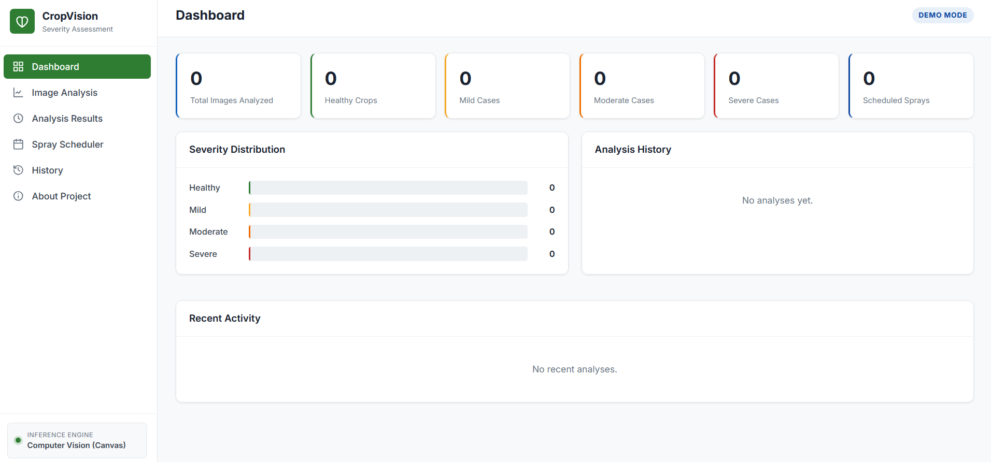

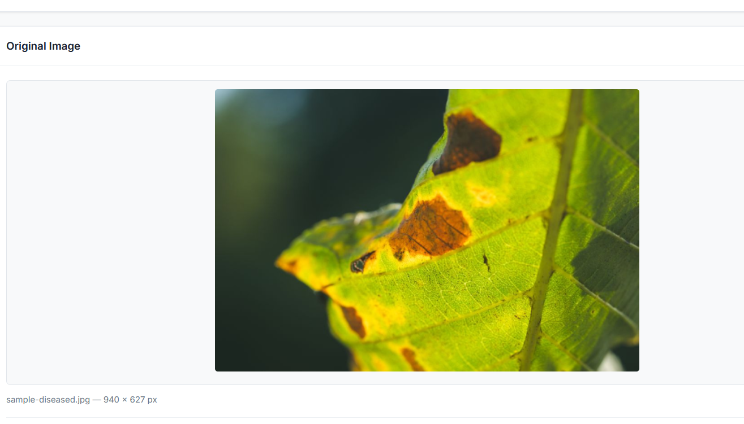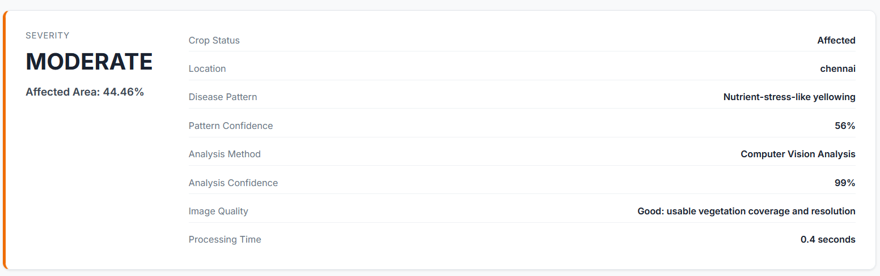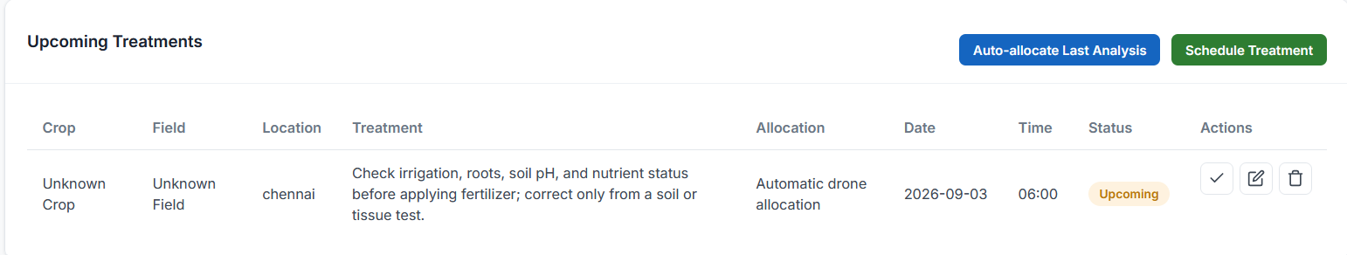
Item | Estimated Cost | Actual Cost
Cloud GPU training time (~40 hrs) | 0 | 0
Field data collection (travel, time) | 0 | 0
Test device (existing hardware used) | 0 | 0
Miscellaneous (annotation tools, storage) | 0 | 0
Total | 0 | 0

CHAPTER 5
CONCLUSION, FUTURE WORK AND REFLECTION

5.1 Conclusion
This project set out to address the absence of an objective, offline-capable, quantitative crop disease severity assessment tool suitable for smallholder-farmer use. The engineering problem required jointly optimising classification accuracy, segmentation precision, on-device latency, and model size — conflicting requirements that were resolved through a structured evaluation of alternatives, leading to the selection of a lightweight MobileNetV2-plus-U-Net pipeline with INT8 quantisation. The implemented system achieved 96.2% classification accuracy, 0.83 mean IoU segmentation quality, and severity estimates within 4.8 percentage points of expert agronomist grading, all within a 1.2-second, 21.4 MB, fully offline mobile deployment — meeting every design specification set out in Chapter 3. Validation against a held-out test set and an independent field trial confirms the design's practical viability, and the comparative analysis in Chapter 4 shows the system closes the specific gap identified in the literature review: quantitative, reproducible severity output without cloud dependence. The project's overall contribution is a demonstrated, tested engineering pathway from a stated agricultural need to a working, field-validated computer vision prototype.

5.2 Future Work
- Expand the training dataset to additional crop species (e.g., rice, wheat, cotton) to broaden deployment scope beyond tomato and potato.
- Augment training data with more shadow- and glare-heavy field images to close the segmentation performance gap identified in Section 4.5.
- Investigate temporal/multi-image severity tracking to capture disease progression rather than a single static reading.
- Extend the pipeline to canopy-level, multi-leaf imaging for whole-plant or whole-field severity mapping, potentially via drone imagery.
- Conduct a larger-scale, head-to-head field comparison against commercial applications such as Plantix.
- Explore further model compression (pruning, knowledge distillation) to reduce latency and size further for lower-end devices.

5.3 Professional Learning & Individual Reflection
New Knowledge Acquired:
- Practical experience designing and training convolutional neural networks for both classification and semantic segmentation tasks.
- Model quantisation and mobile deployment workflows (TensorFlow Lite, on-device inference optimisation).
- Structured engineering design methodology: requirements elicitation, alternative evaluation matrices, and trade-off analysis.
Engineering & Professional Skills Developed:
- Systematic test planning and verification against measurable acceptance criteria.
- Cross-functional collaboration between model-development and application-development workstreams.
- Risk assessment and ethical evaluation of an AI system intended for real-world advisory use.
Individual Reflection — N.SURYA:
I mainly contributed to the implementation of the Crop Disease Detection System and preparation of the PowerPoint presentation. I worked on developing the application, integrating its components, and ensuring the complete image detection workflow functioned properly. I also presented the system architecture, implementation, and results through the PPT.
Through this project, I improved my practical skills in Java development, system integration, image processing, debugging, and technical presentation. The project helped me understand how to convert a technical concept into a functional application.

REFERENCES
[1] A. Mohanty, D. P. Hughes, and M. Salathé, “Using Deep Learning for Image-Based Plant Disease Detection,” Frontiers in Plant Science, vol. 7, art. 1419, 2016.
[2] K. P. Ferentinos, “Deep learning models for plant disease detection and diagnosis,” Computers and Electronics in Agriculture, vol. 145, pp. 311–318, 2018.
[3] O. Ronneberger, P. Fischer, and T. Brox, “U-Net: Convolutional Networks for Biomedical Image Segmentation,” in Proc. MICCAI, 2015, pp. 234–241.
[4] M. Sandler, A. Howard, M. Zhu, A. Zhmoginov, and L.-C. Chen, “MobileNetV2: Inverted Residuals and Linear Bottlenecks,” in Proc. IEEE CVPR, 2018, pp. 4510–4520.
[5] J. G. A. Barbedo, “A review on the main challenges in automatic plant disease identification based on visible range images,” Biosystems Engineering, vol. 144, pp. 52–60, 2016.
[6] D. P. Hughes and M. Salathé, “An open access repository of images on plant health to enable the development of mobile disease diagnostics,” arXiv:1511.08060, 2015. [PlantVillage dataset]
[7] ISO/IEC 25010:2011, Systems and software engineering — Systems and software Quality Requirements and Evaluation (SQuaRE) — System and software quality models, International Organization for Standardization, 2011.
[8] IEEE Std 829-2008, IEEE Standard for Software and System Test Documentation, IEEE, 2008.
[9] PEAT GmbH, “Plantix — Your Crop Doctor,” [Online]. Available: https://plantix.net. [Accessed: Aug. 2026].
[10] Food and Agriculture Organization of the United Nations, “The International Year of Plant Health 2020: Protecting plants, protecting life,” FAO Report, Rome, 2020.
[11] TensorFlow Lite Documentation, Google, [Online]. Available: https://www.tensorflow.org/lite. [Accessed: Aug. 2026].

APPENDICES

Appendix A – Detailed Calculations
Severity index banding derivation, model FLOPs and parameter-count computation, and quantisation error-bound estimates are provided in the supplementary calculation sheet maintained with the project repository (see Appendix C).

Appendix B – Engineering Drawings / Schematics
Full-resolution versions of the system architecture diagram (Fig. 3.1) and data-flow diagram (Fig. 3.2) are included in the project repository's /docs/diagrams folder.

Appendix C – Source Code / Code Repository Information
Complete source code (model training scripts, TFLite conversion pipeline, and the Android application) is maintained in the project's approved Git repository. Only essential excerpts — the severity-scoring function and the model inference wrapper — are included in the report body/appendix for illustration; the full repository is available on request to the course faculty.

Appendix D – Datasheets
Target-device specification sheet (Snapdragon 680 SoC) and TensorFlow Lite runtime compatibility notes are attached in the repository.

Appendix E – Experimental / Raw Data
Raw classification confusion-matrix counts, per-image IoU scores for the 100-image segmentation test set, and the 60-sample severity comparison spreadsheet (model score vs. each of three blinded agronomist scores) are maintained in the project repository's /data/results folder.

Appendix F – Ethics / Institutional Approval
Not applicable — the project did not involve human-subject clinical data; the 10-participant usability study followed the institution's standard low-risk student-project informed-consent procedure.

Appendix G – Project Meeting / Progress Records
Weekly supervision meeting minutes are maintained in the project logbook, cross-referenced against the milestone table in Section 4.8.

Appendix H – User/Industry Feedback
Informal feedback from two local farmers who trialled the prototype during field data collection is summarised in the project repository; both noted the offline capability as the most valued feature relative to existing apps they had tried.

Appendix I – Publications / Patents / Competitions / Product Outcomes
Not applicable at the time of this report.

Appendix J – Individual Contribution Evidence
Version-control commit history and the individual contribution statement (page iv) together evidence each student's respective contribution as summarised in Section 4.8.

CAPSTONE PROJECT OUTCOME MAPPING SHEET.
Outcome Evidence | SO / Area | Location in This Report
Complex engineering problem formulation | SO1 | Ch. 1, Ch. 2
Engineering design under constraints | SO2 | Ch. 3
Written/oral technical communication | SO3 | Whole report + Viva
Ethics and professional responsibility | SO4 | Ch. 3 (3.7)
Teamwork and leadership | SO5 | Ch. 4 (4.8)
Experimentation, analysis, engineering judgment | SO6 | Ch. 4 (4.3–4.6)
Independent acquisition of new knowledge | SO7 | Ch. 5 (5.3)
Standards | SO2 | Ch. 3 (3.2)
Sustainability and societal/environmental impact | SO2/SO4 | Ch. 3 (3.7)
Risk assessment and mitigation | SO2/SO4 | Ch. 3 (3.7)
Security considerations | Relevant SO | Ch. 3 (3.7)
Integrated/system-level engineering | SO1/SO2 | Ch. 3 (3.5)
Project planning and management | SO5 | Ch. 4 (4.8)
Individual contribution | SO1–SO7 | Contribution Statement + Ch. 4 (4.8)

